International Motor Company Ltd.

Vehicle Signifiers and Affordances



CEN 1789:2007 is the [European Union](https://en.wikipedia.org/wiki/European_Union) [standard](https://en.wikipedia.org/wiki/International_standard) for [ambulances](https://en.wikipedia.org/wiki/Ambulances) and medical transportation vehicles. This European standard specifies requirements for the design, testing, performance and equipping of road ambulances used for the transport and care of patients. This standard is applicable to road ambulances capable of transporting at least one person on a stretcher.

International Motor Company Ltd.

Standard Ambulance Signifiers

CEN 1789 European Standard

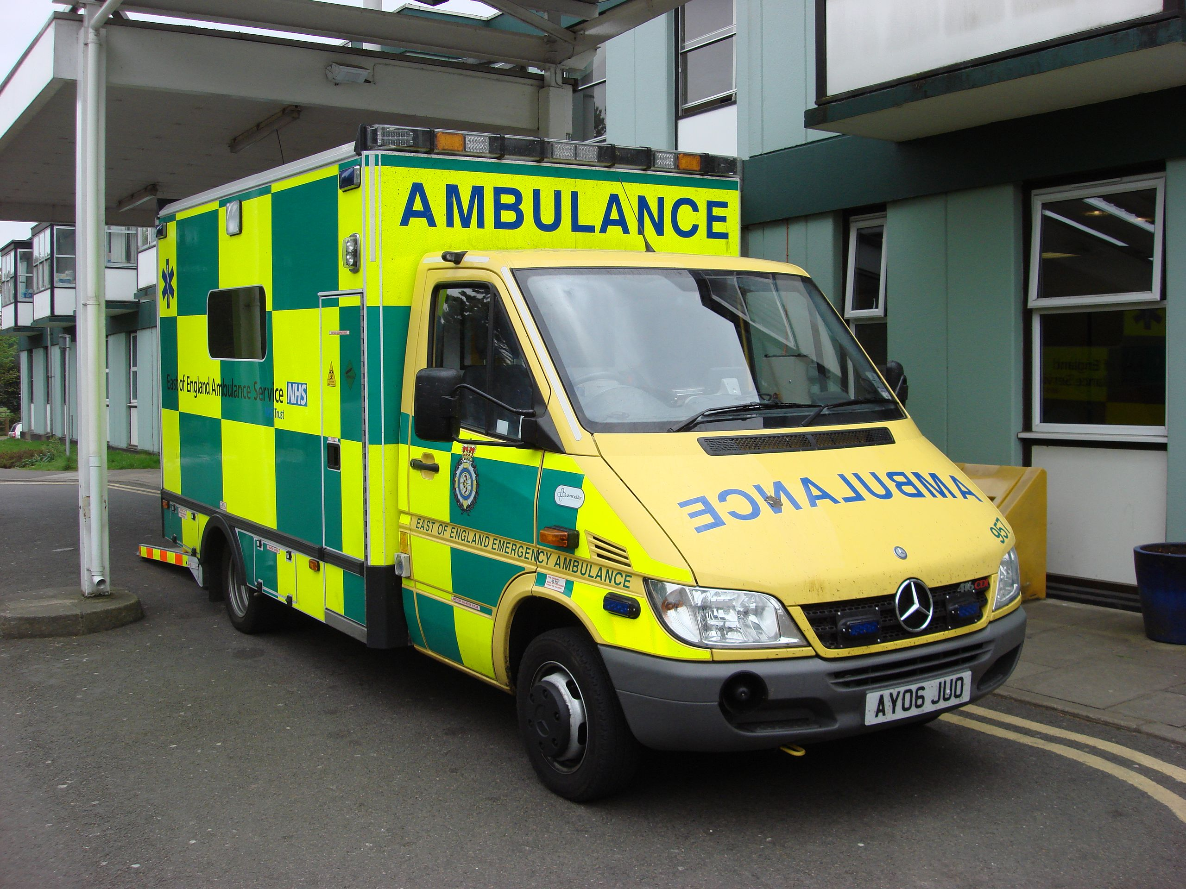

The vehicle will follow the CEN 1789:2007 standard which is a European standard for medical transportation vehicle. First thing to check is the color of the ambulance. Technically, the CEN 1789 defines the color of the ambulance to be green and yellow (See picture). The picture also shows an example of a European ambulance which adopted these colors and which also uses the same vehicle we are taking inspiration from. This is an optimal solution because those colors are very bright so the vehicle is easily visible during the day and, more importantly, during the night (Green is the second most visible color at night). The precise color of the ambulance is EuroYellow RAL1016. Moreover, they are also easy to remember since usual cars can not use this combination of colors. Furthermore, the vehicle has a very similar shape to an ambulance, which is already a signifier per se. Moreover, those colors have been chosen also because yellow is visible

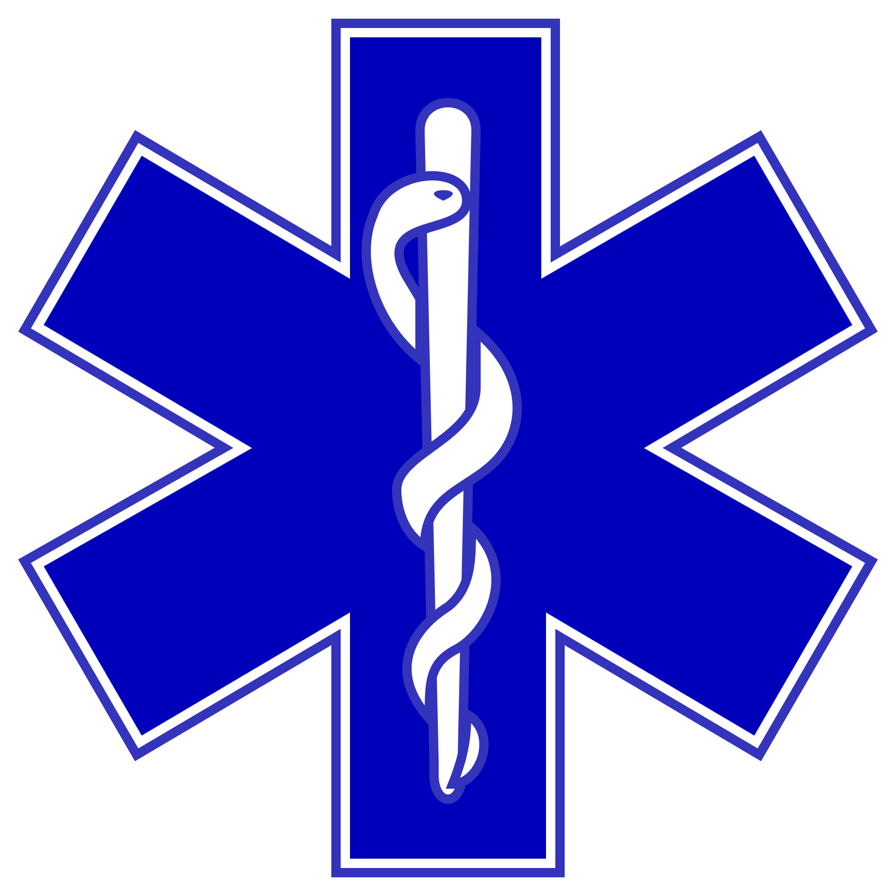

by every individual with colorblindness and the combination is still very eye-catchy also for them.

In addition to the color, the vehicle will also adopt some other signifiers from the standard. As probably already imagined, the vehicle will also need a sound signifier. In order to fulfill this requirement, the vehicle will adopt the same sirens as normal ambulances. This means, same colors, same frequency and same sound.

The exterior of the car will also include figures that are a standard internationally. For example, the Star Of Life must be painted on both sides and must be at least 500mm in diameter. In case of the ambulance being part of International Red Cross and Red Crescent Society, the emblem will be replaced by the Emblems of the International Red Cross and Red Crescent Movement. In the front there will also be painted AMBULANCE, but on the other way around so that it can be read more easily. Unfortunately, this word is not used internationally and it is only an English word. Because of that, the word will be written in the country of use official language.

All of those things combined can be also considered as an affordance. In fact, as soon as the vehicle is seen by a person who needs rescue, they know already what to do and what to expect, due to past experience. People can in face easily associate the two vehicles.

The interior of the ambulance and all the medical equipment inside of it will be according to the same standard. This means that personal inside the ambulance will move comfortably because they are already trained in the same environment. In reality, this is true only for the instruments. In face, we expect the experience of driving it will be a bit different than in a normal ambulance due to the differences in the environment. Because of that, probably drivers and paramedics that operate in the ambulance will need more training.

Even though the user interface will be as straightforward as possible and not overwhelming, there might be the necessity for some training regarding the signals the vehicle will send. In fact, since we are expecting our vehicle to be autonomous, there is the necessity to inform the paramedics about what is going on outside. This is crucial for safety operations.

The first information that the car needs to show is whether it is in autonomous driving mode or if it is in normal mode.

When in autonomous mode , the car will need to notify whether it is able to keep moving according to the path or if there is an obstacle that blocks it. Following, the vehicle needs to communicate which decision is taking. Will the vehicle calculate another path or it is stuck? What will it do if it is stuck? The driver and personal on board will have answers to those questions by sound and vision feedback. In fact, the car will use ambient lighting for this purpose.

* Yellow if the car stopped because of an object, followed by green if it found another path.
* Yellow and the Red if the car is stuck, this also means that the car will send information immediately to the operation tent or hospital regarding position, obstacle and picture of the inside (for the condition of the rescued person) and the outside (to facilitate rescue).
* Red with sound signal if there’s a problem within the car and it is not able to drive anymore. It will also apply the same procedure.

Vehicle-Specific affordances and signifiers

International Motor Company Ltd.

In addition, the car needs to notify if the road ahead is in bad condition because in case of sensible operation this is an extremely important factor to take in consideration.When the road is bumpy or slippery, surgical operations are extremely risky. Even though the car will be provided with suspensions, the experience shows that they do not create a perfect steady environment, or at least not steady enough for some kind of operations.

The car will also use sound signals to communicate other information. In fact, the distance between the position of the ambulance and the hospital, and off course relative ETA (estimate time of arrival), are most of the time crucial when rescuing people. This sound signal will not be continuing but it will have a certain frequency, for example every 10% of the distance. It is important to note that this is not the chosen value because this might also represent an annoyance for the paramedics and the real value will be evaluated with user tests.These information will be also displayed in a screen within the ambulance.

The same display will also show the position of the other similar vehicle, vehicles which have this functionality, so that the operators can understand how is the situation going and better realize how to behave.

Unfortunately, due to inaccuracy of the sensors and human error, there might be cases where the autonomous mode does not behave as expected. In this situation, the paramedics should be able to immediately stop the car and take over with the driving. In order to do so, the classic STOP red button placed in a convenient position in the back and in the front will do the job. In fact, due to its simplicity, everyone understands its meaning only by a single glance.